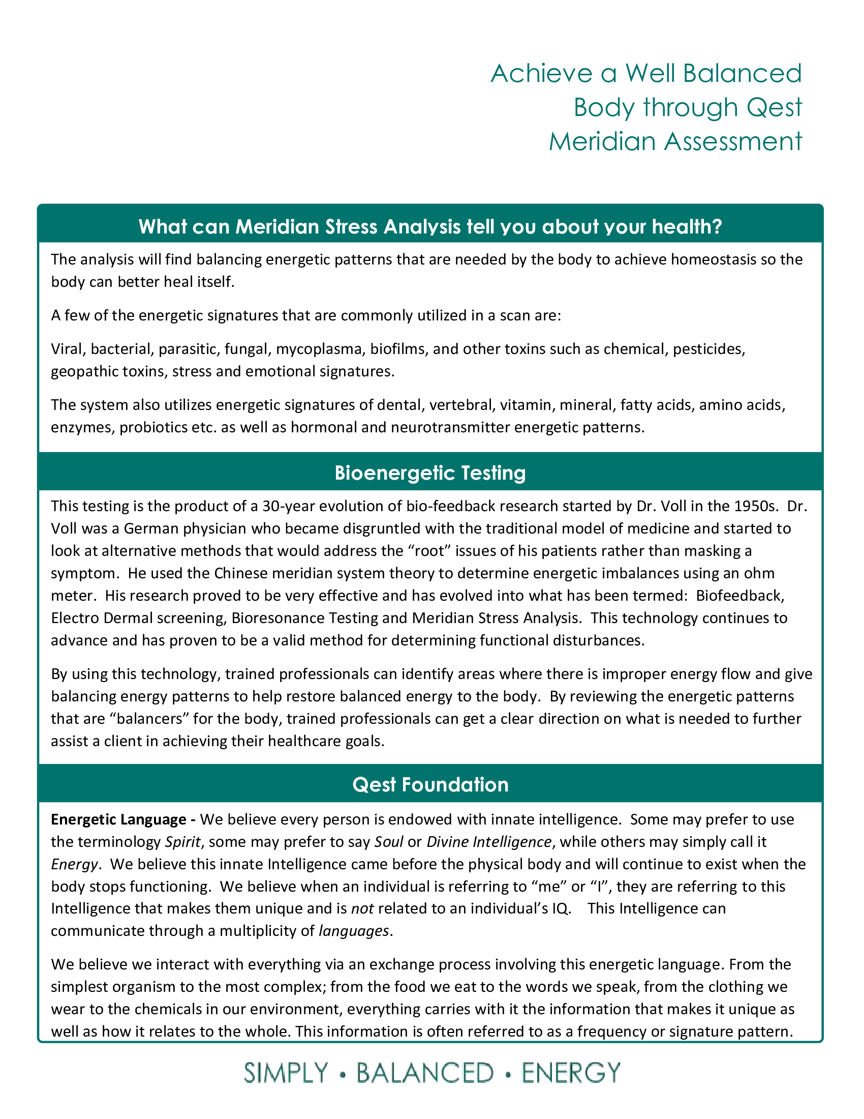

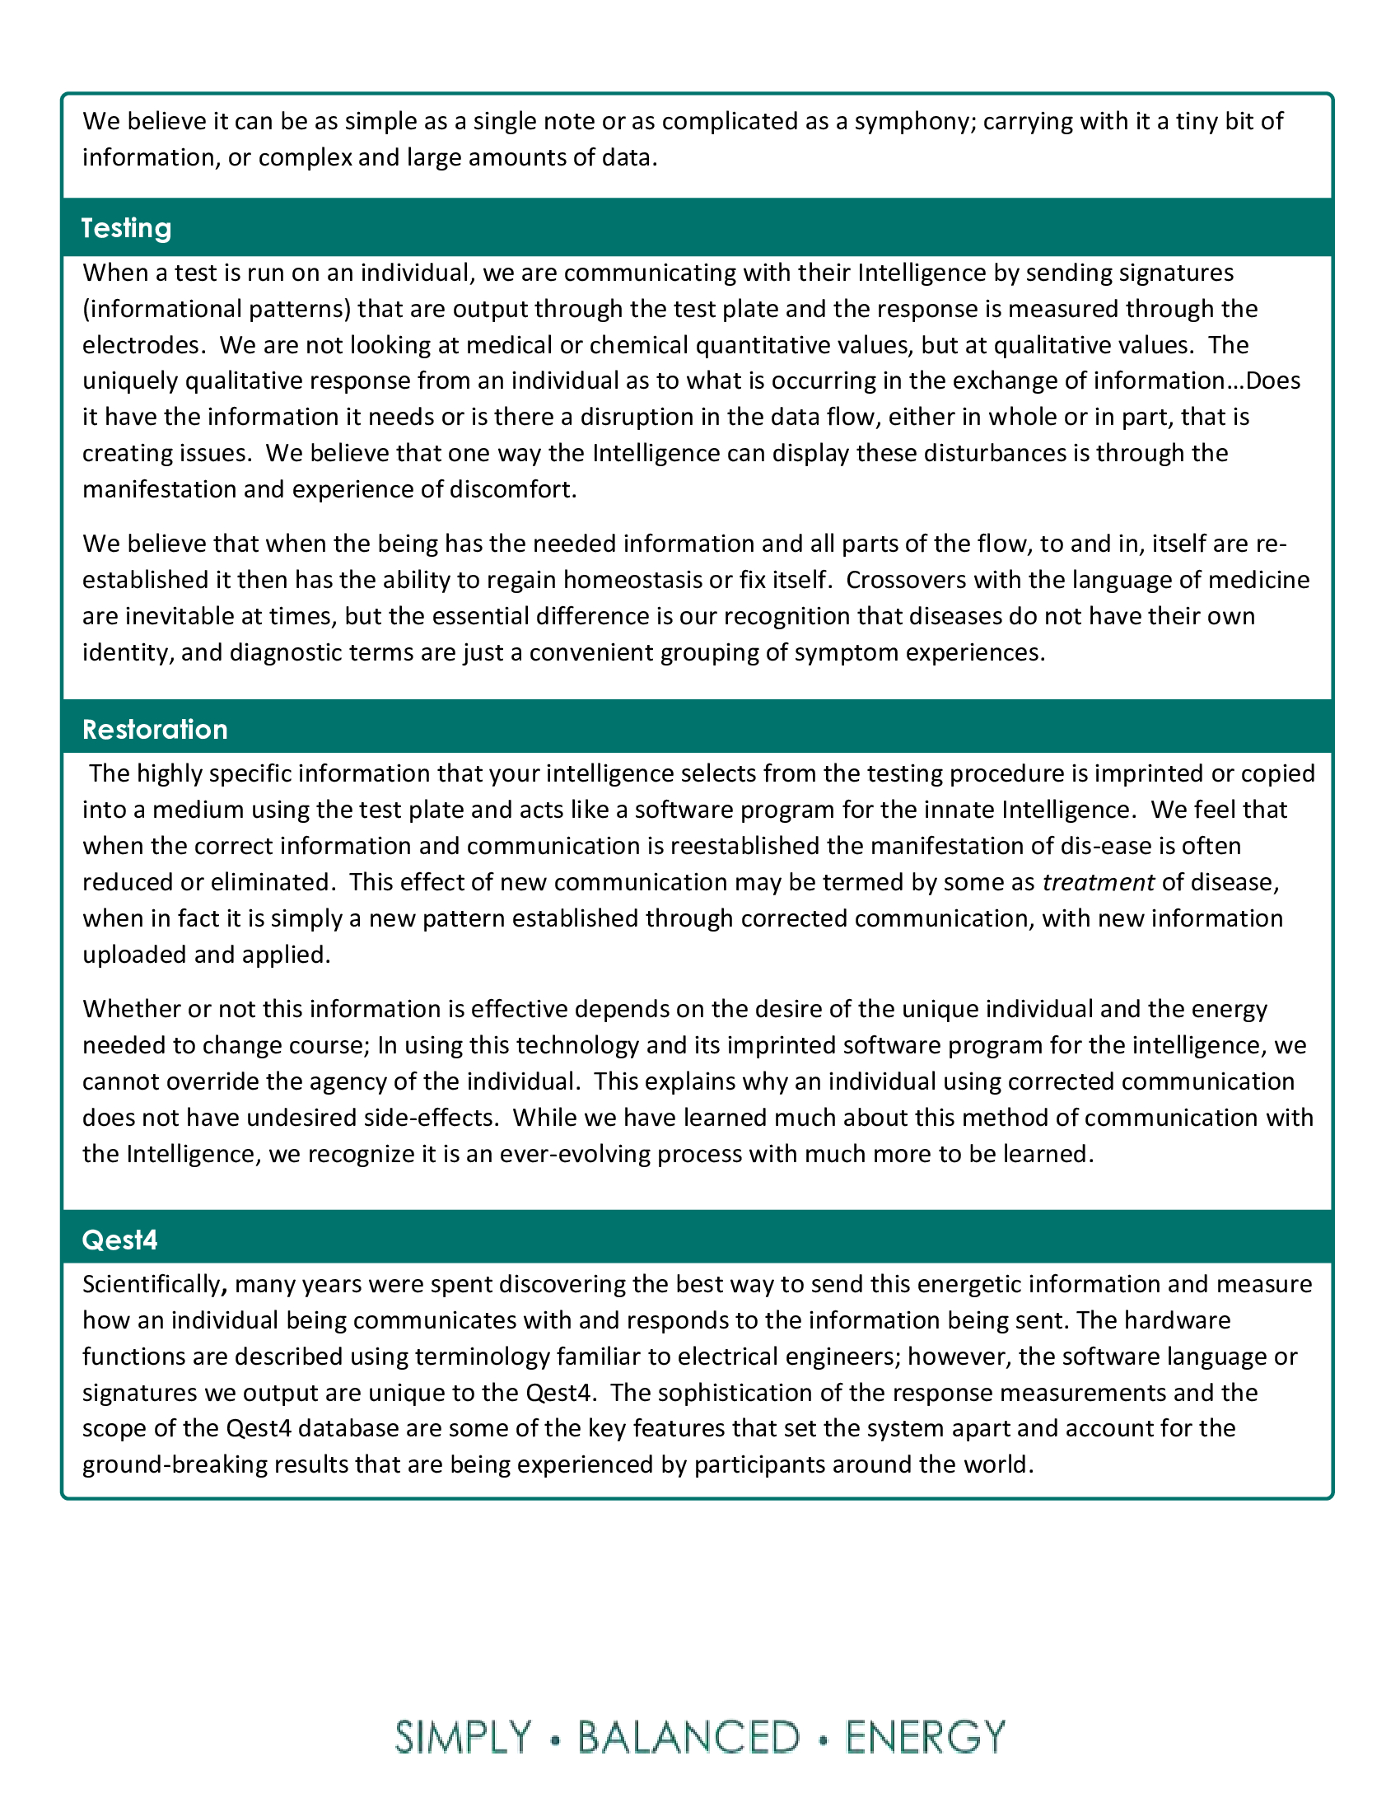

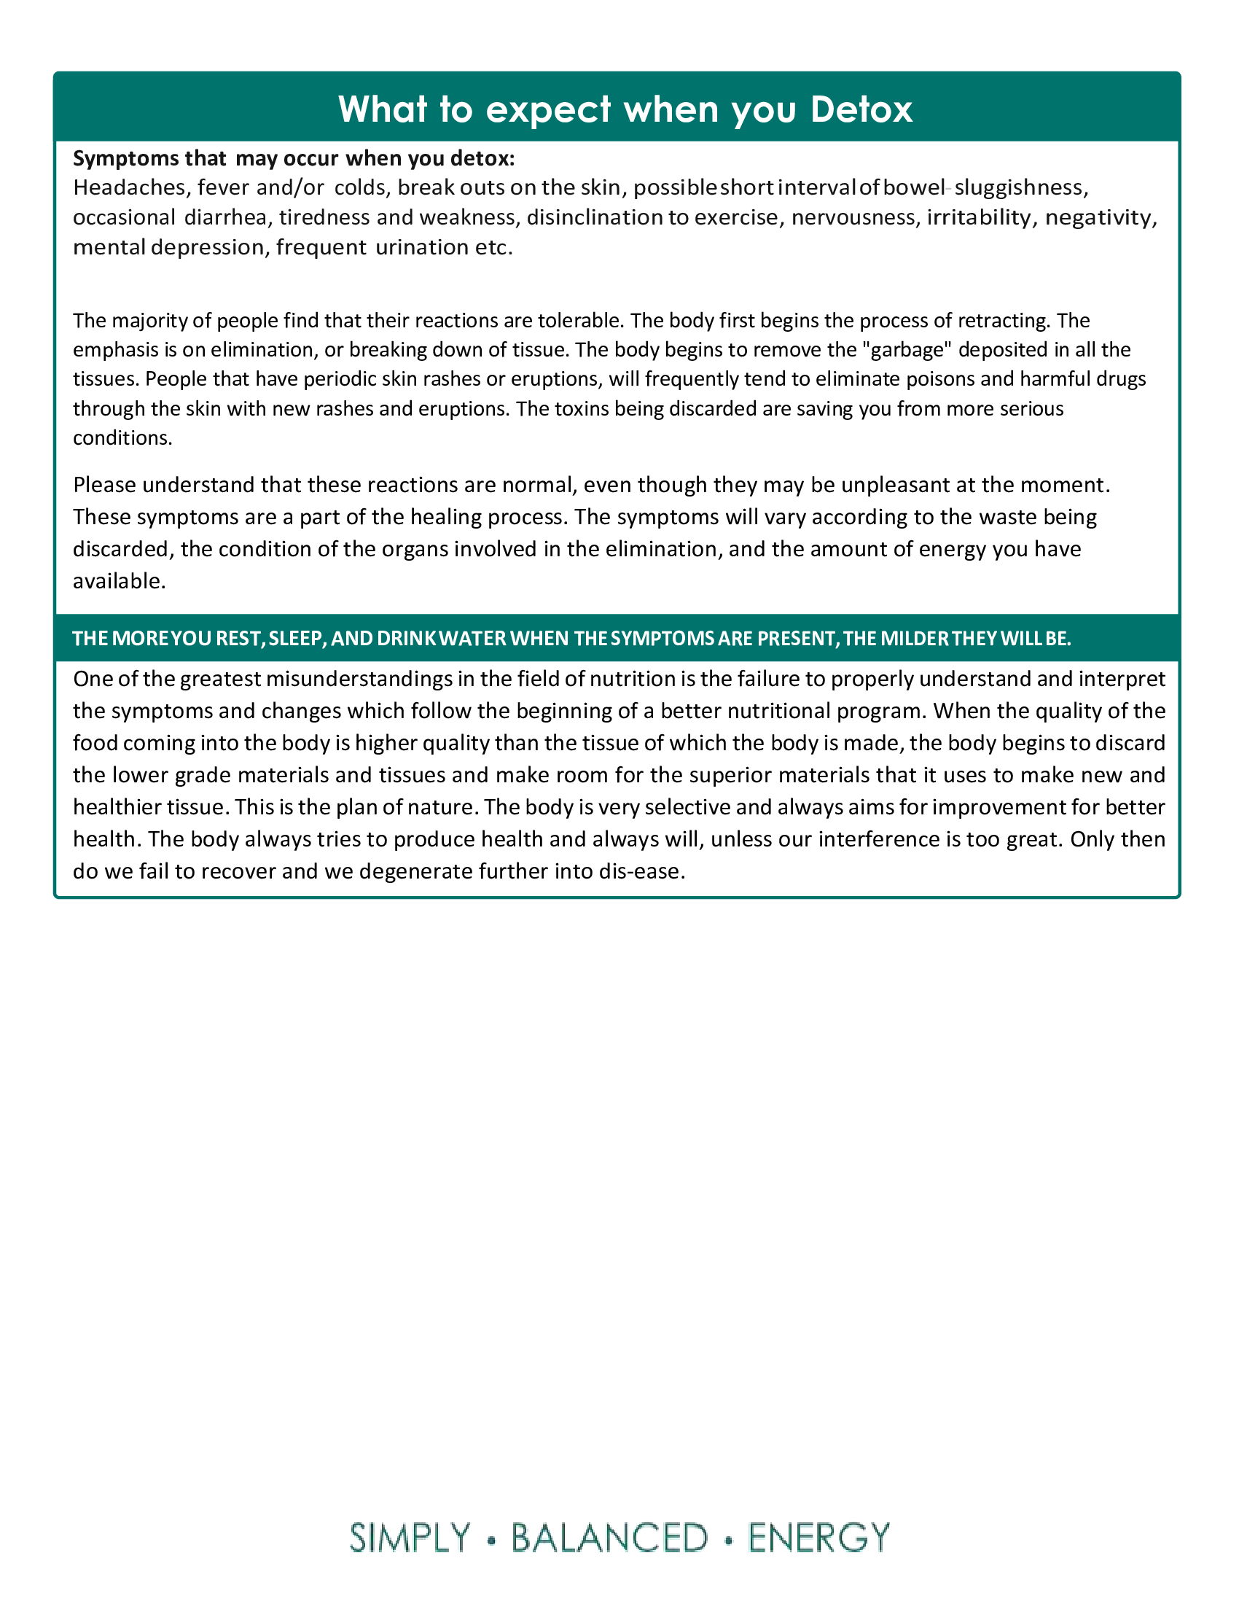

Xceptional You Wellness LLC
504-334-8889
xceptionalyouwellness@yahoo.com
1799 Stumpf Blvd Bldg 4 Ste 4, Gretna LA, 70056

